

Submitted by: Spogmai jan

Submitted to : Dr.syed jawad hussain

Date of submission : 10/October/2024

Subject: Programming fundamental

ASSIGNMENT : 01

**Calculator making in C++**

**Code:**

#include<iostream>

using namespace std;

int main( ){

double num1,num2 ;

char op;

cout<<"Enter the operator (+ - * / ):" ;

cin>>op;

cout<<"Enter the two numbers one by one:";

cin>> num1>> num2;

switch (op)

{

case '+':

cout << num1 <<op <<num2 <<"="<<num1+num2 <<endl;

break;

case '-':

cout << num1 <<op <<num2 <<"="<<num1-num2 <<endl;

break;

case '*':

cout<< num1 <<op <<num2 <<"="<<num1*num2 <<endl;

break;

case '/':

if (num2 == 0.0)

cout<<" Divide by zero situation"<<endl;

else

cout<< num1 <<op <<num2 <<"="<<num1/num2 <<endl;

break;

}

return 0;

}

**Results**

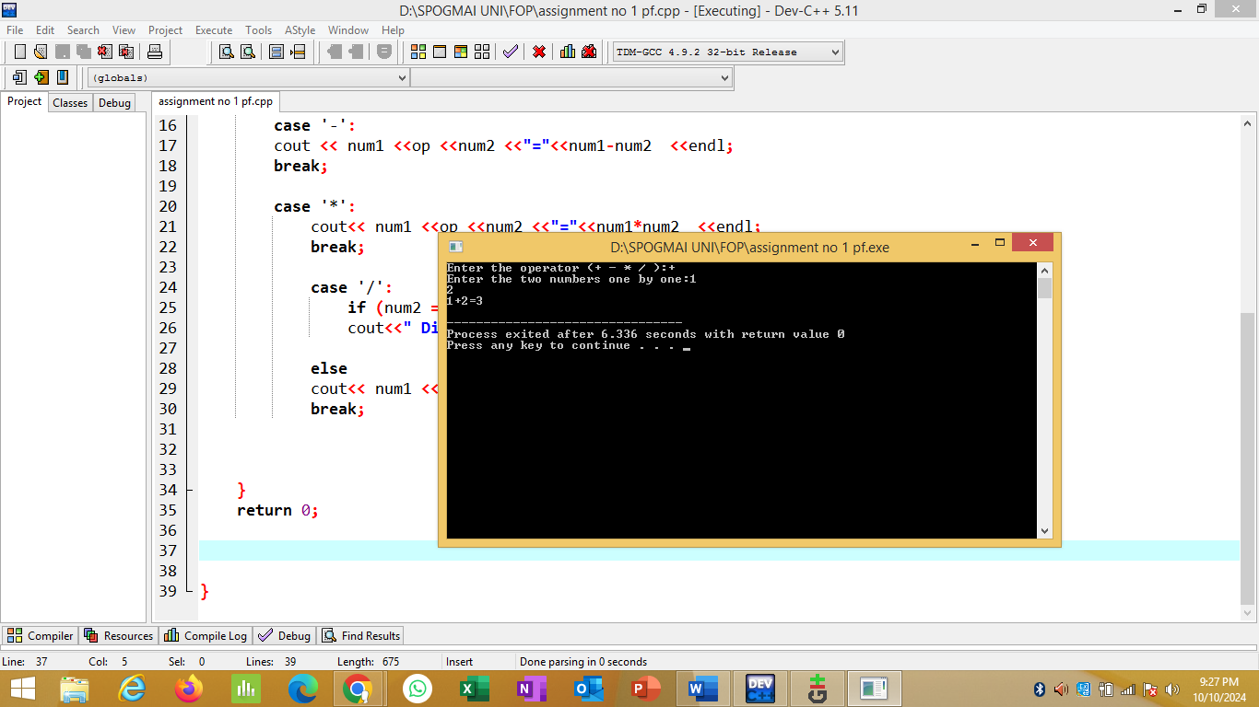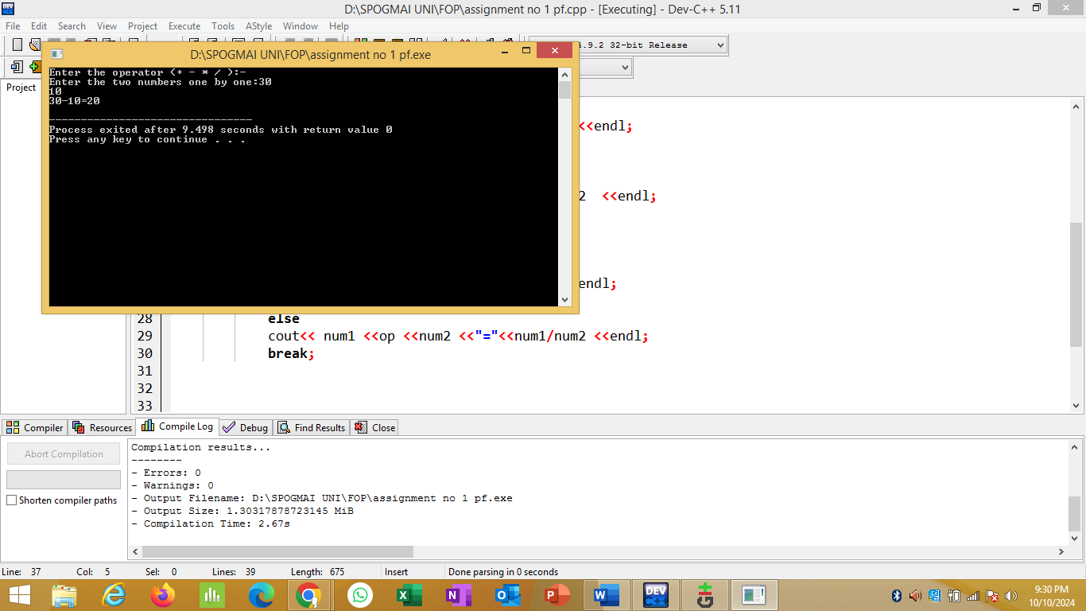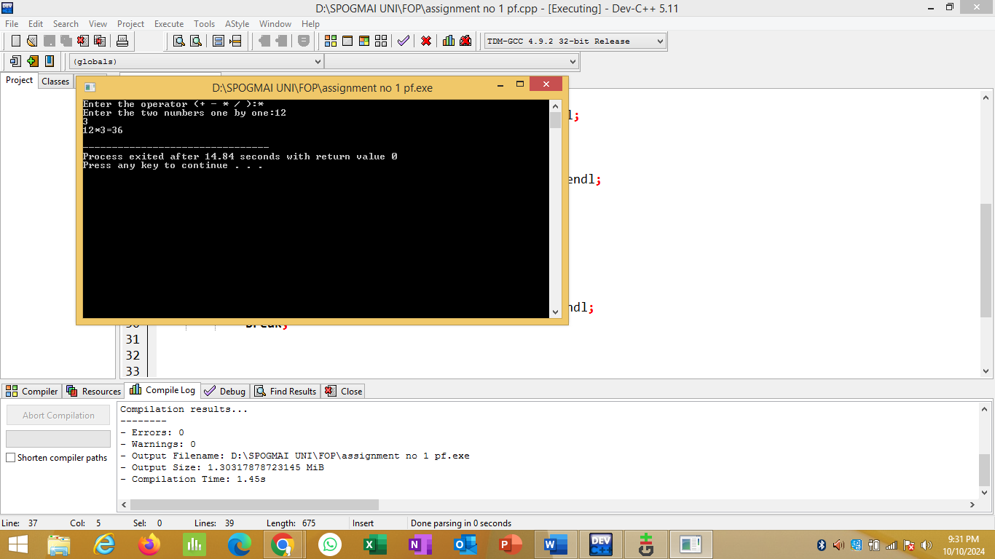



**……………..……………………….the end…………………………………………………..**